Project Charter Template Instructions

The purpose of a Project Charter to outline the need being addressed, problem statement, proposed solution, scope of the project, and outline a timeline and projected costs associated with the project. The project charter is typically completed during the first two phases of the design process. The use of a template will allow Engineering Service Learning teams to complete the Project Charter in a timely manner. Users should insert text into the document preserving the styles that has been preset. The prompt questions have been provided to help with the development of the text and are in blue font.

REMOVE ALL BLUE TEXT PRIOR TO SUBMISSION.

Direct any questions regarding the project charter to your Teaching Assistant or Engineering Service Learning staff.

DELETE THIS PAGE SHOULD PRIOR TO COMPLETION AND SUBMISSION OF THIS DOCUMENT.

**Engineering Service Learning**

**at UC Merced**

**Project Charter**

Team: [Team Name]

Project: [Project Title]

**USE THE BULLETED QUESTIONS TO HELP YOU ADDRESS THESE THREE GENERAL TOPICS. NOTE THAT ALL QUESTIONS DO NOT NEED TO BE ANSWERED.**

**Problem statement:** concise statement of your client (community partner organization), your client's specific problem that you will be addressing, who will benefit, and how. Provide information on the constraints, and resources.

* Who is the client (community partner organization) for this project?
* What is the overall mission of your community partner?
* Who does your community partner server? Who are their clients?
* What services does the client (community partner organization) provide to their clients?

**Solution statement:** concise statement of the solution that you will provide to meet the needs of the client (community partner organization). Describe the solution, including who will be affected (stakeholder groups), economic impact, adding capacity to the organization, and addressing the pressing need.

* Why are you doing the project (i.e. what is the motivation or need for the project?
* What specific problem/need are you addressing?
* How does your project fit within the mission of your client (community partner organization) and your team?
  + How does this project help the mission of the community partner?
* What are going to be the project deliverables, and effects on the client (community partner organization)?
* Will someone else be affected by the project after completion? If so, who?
  + Who has vital interest in the project’s success?
* What will be the economic impact of the project?
  + Will it save time for the community partner? Quantify how much $ in time savings.
  + Will this project result in an added capacity? What are the economic benefits to providing more services?
  + Will this project result in a new or improved way to bring in funding?

**Project timeline:** include a graphical timeline for the project and a description of the major milestones with projected deadlines.

**PROVIDE A GRAPHICAL TIMELINE AND A PARAGRAPH OUTLINING THE TIMELINE**

* What is the start date of the project?
* What is the expected date for completion of the project?
  + Include assessment of the fielded project into this date.
* What are the milestones and deadlines for the project? (these are not design phases, but could be related)
* Are there any factors that could negatively influence your timeline?
  + What are these factors?
  + How will you mitigate for them?

**Budget**

**INCLUDE A PROJECTED BUDGET FOR THE PROJECT (TABLE)**

* What is the projected budget for the project?
* What categories make up the budget for the project?
* What factors might cause cost overruns?

**DO NOT INCLUDE SPECIFIC DETAILS OF ITEMS YOU PROJECT TO PURCHASE IN THE TABLE.**

* Include a summary of the budget and how the categories will be used in the project. Budget categories may include costs associated with materials, travel, and other expenses associated with the project. **EXAMPLE:**

**EXAMPLE:**

The Merced County Rescue Mission (MCRM) works to serve the homeless community within Merced County and help them move towards a better life. The rescue mission provides both physical and spiritual needs, such as in the form of beds, food, clothing, personal care, and spiritual counseling. One such program within the MCRM, is the Hope Respite Care program which provides acute and post-acute medical care for homeless persons who are too ill or frail to recover from a physical illness or injury on the streets, but are not ill enough to be in a hospital and allows for a safe place to rehabilitate. Hope Respite Care offers patients a supportive environment with meals, oversight of medical treatment, follow-up care, and long-term housing options through case management. Through this program, the savings to Merced County was approximately $1.3 million last year alone in reoccurring emergency room costs.

The Hope Respite Currently program in its current state is able to provide support approximately twenty patients with nine rehabilitation beds. To manage the caseload of these patients, Hope Respite uses a paper-based filing system to hold medical records and patient profiles. This current system lacks easy way for the MCRM to track and report on the services provided through the Hope Respite project. As a result, many hours are spent compiling information to provide funding agencies regarding the services provided annually.

To address this challenge the MCRM has recently acquired a license to Apricot, an electronic file system that will be used to input and track client information for better case management and reporting. However, the transfer of the case management information to this new digital environment is costly in terms of time and money. The MCRM Engineering Service Learning team will be creating a system that will transfer all relevant case management information from its current paper form to the Apricot system. One hundred percent accuracy of the data transferred from the paper to the digital format is required. The result of this project will be to provide Hope Respite patient profiles within Apricot, and allow for more accurate reporting.

This reduction of administrative duties will allow for greater support for the homeless community in Merced County and the expansion of services to this community. It is estimated that Hope Respite will be able to increase their case load by at least 50%. The increased ability to track the serviced provided will also allow for improved reporting for grant applications, and other funding sources.

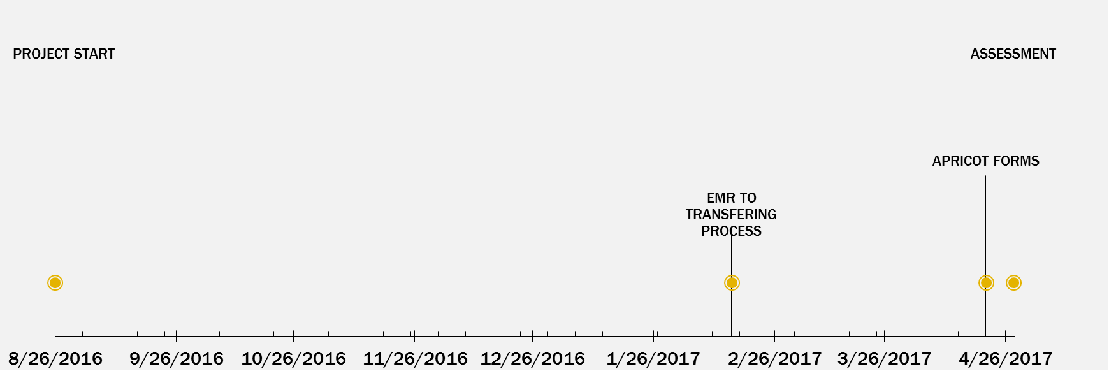

The anticipated duration of the Hope Respite Project is approximately 8 months, or 2 semesters, concluding in late April of 2017. The project start date is August 26, 2016. In the first part of January of 2017, the transfer process will be identified including the scanning of paper documents into a digital format. By mid-April of 2017, the transfer of digital forms to the Apricot management system will begin, followed by an assessment of the transfer process.

Insert the expected budget for the current semester through a table or a figure listing the major categories of the budget (i.e. travel, project supplies, training, etc.). DO NOT INCLUDE SPECIFIC DETAILS OF ITEMS YOU PROJECT TO PURCHASE IN THE TABLE.

**EXAMPLE:**

|  |  |
| --- | --- |
| **Item** | **Cost** |
| FAA License | $150 |
| Travel | $300 |
| Project Materials | $200 |
| TOTAL | $650 |

The total budget for this semester is $650. The new pilot will need an FAA pilot license, which will cost $150. Travel will cost around $300, for going to any off campus events or to meet clients, and to visit the farm. Project materials are anticipated to cost $200 for things such as batteries, rotors and the camera mount.

I agree to the afor stated project with its associated deliverables, timeline and deadlines.

Community Partner Name (print) Signature Date

Team Leader Name (print) Signature Date

EngSL Staff Name (print) Signature Date